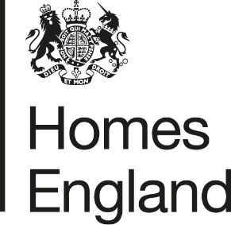
Making homes happen

CITY DEAL EXECUTIVE & STEWARDSHIP BOARD 6th October 2020
Homes England Quarterly Monitoring Progress Update Report
Quarter 2 2020 / 21
- Report Overview
  - This report provides an update on the progress that has been made in relation to the Homes England sites that form part of the Preston, South Ribble and Lancashire City Deal. The update relates to the progress that has been made during the second quarter of the 2020 / 21 financial year, between 1st July and 30th September 2020.
  - The report focuses on key delivery milestones, finances invested, and outputs generated, and provides a breakdown of the key risks and any emerging issues across the portfolio of sites.
- Recommendation
  - Homes England recommends that the Executive and Stewardship Board:
Note the content of this report and the progress made by Homes England during the second quarter of 2020 / 21.
- Homes England Site Highlights
  - As reported in the previous quarterly update; the global pandemic ‘Covid-19’ impacted the delivery of development across all of the Homes England City Deal sites, with all developers ceasing operations for a period of time during ‘lockdown’ through the first quarter of the 2020 / 21 financial year.
  - Whilst the effects of Covid-19 continue to be realised, the delivery of development across Homes England’s City Deal sites has resumed for the second quarter of 2020 / 21 with housing completions rising once again and property sales taking place.
  - Key highlights from the second quarter of 2020 / 21 are set out in the table below:
Phase / Plot | Status | Completions/  Total Units | Completions  (July – Sept) | Finance  (July – Sept) | Summary
1. Cottam Hall
Phase 1 | Phase completed by Barratt Homes | 104 / 104 (100%) | n/a | n/a | n/a - Build out complete
Phase 2 | Story Homes on-site | 123 / 283 (43%) | 0 | n/a | Developer has resumed build-out of site, further completions anticipated to resume Q3 2020.
Phase 3 | Morris Homes on-site | 12 / 119  (10%) | 9 | n/a | Further 9 completions achieved post-lockdown this quarter. Site build-out continues.
Phase 4 | Conditional deal agreed with Rowland Homes. Reserved matters approved July 2019 | 0 / 141  (0%) | n/a | n/a | Reserved Matters Application for 141 homes was approved on 11th July 2019. Modification to GCN licence has been approved. Homes England has concluded S106 agreement discussions with third parties. It is anticipated that the unconditional stage of the deal will complete and housebuilding to commence Q3 2020 / 21
Phase 5 | Site out to tender for disposal | 0 / 233  (0%) | n/a | n/a | Tender to appoint preferred developer partner published mid-august, with anticipated close Q3 2020.
Phase 6  (Plots 14 and 15) | Both plots (14 and 15) of Phase 6 have now been disposed of on an unconditional and conditional basis to Countryside and Barratt Homes respectively. | 0 / 189  (0%) | n/a | n/a | Plot 14: Countryside has resumed development post-lockdown. First completions estimated Q3 2020.  Plot 15: Disposed of on a conditional basis to Barratt Homes in March Q4 2019/20. No reserved matters application has been submitted yet. A planning pack is expected to be received beginning of Q3 2020.
Local Centre | Disposal of site for Local Centre anticipated Q3 2020 | n/a | n/a | n/a | Homes England continues to negotiate deal with Thistlewood Properties. Anticipated completion Q3 2020.
2. Cottam Brickworks
Access agreement | Ongoing discussion regarding access into adjacent land via Homes England site | 0 / 260  (0%) | n/a | n/a | Discussion ongoing to find a resolution to the site’s access rights. Homes England monitoring the ongoing dialogue between landowner and LCC.
3. Land at Eastway
Residential Plot | Story Homes on-site completing build out | 110 / 329  (33%) | 0 | n/a | Story Homes has resumed build out following lockdown, but no completions have occurred this quarter.
Commercial Plot | Site under conditional contract with HSB Healthcare | n/a | n/a | n/a | Delivery of a new access into the site has been slightly delayed, with start on site now anticipated Q3 2020. Likely timescale for completion is 9 months.
4. Whittingham Hospital
Phase 1 | Taylor Wimpey has completed Phase 1 | 150 / 150 (100%) | n/a | n/a | Taylor Wimpey has completed build out of Phase 1.
Phase 2 | Preferred bidder Barratt David Wilson selected Q4 2019/20. | 0 / 232  (0%) | n/a | n/a | Preferred bidder Barratt David Wilson selected at the end of March 2020 and conditional contract agreed. Reserved matters likely to be submitted Q3 2020.
Phases 3 and 4 | Not yet released. Disposal phases and options to be reviewed in 2020 / 21. | 0 / 512  (0%) | n/a | n/a | Current strategy is to dispose of part of the next phase (circa 40 units) sometime this financial year, however this is currently being considered, particularly the approach to drainage across both phases.
5. Preston East
Expansion Area | Marketing of site concluded this quarter. | n/a | n/a | n/a | Marketing of site now closed this quarter, with 13 offers received all for employment-led warehousing / distribution centres. Homes England currently assessing bids, with view to agree conditional contract (subject to planning) with preferred developer by Q4 2020/21.
Sector D | Build-out of site complete. | n/a | n/a | n/a | Build-out of site complete.
6. Pickerings Farm
n/a | Masterplan and outline application submitted | 0 / 275  (0%) | n/a | n/a | Updated version of Masterplan submitted August 2020. Masterplan refused at SRBC planning committee held 17th September 2020.  Homes England will continue to work with SRBC officers on the masterplan and outline planning application.
7. Altcar Lane
n/a | Continued build-out of site by Lovell | 38 / 200  (19%) | 13 | n/a | 13 completions have been recorded during Q2 2020 as Lovell has resumed build out of the site after lockdown
8. Croston Road North
n/a | Keepmoat selected as preferred developer in October 2019 | 0 / 400  (0%) | n/a | n/a | Hybrid application including reserved matters for the 400 units was submitted by Keepmoat in July 2020. It is anticipated that this will go to committee mid-October.
9. Croston Road South
Phase 1 | Miller Homes has completed Phase 1 | 96 / 96 (100%) | n/a | n/a | Miller Homes has completed build out of Phase 1
Phase 2 | Miller Homes on-site | 70 / 79  (86%) | 2 | n/a | 2 completions have been recorded on Phase 2 of this site during this period.
10. Brindle Road
n/a | Complete | 46 / 46  (100%) | n/a | n/a | All units completed and all finances paid.
11. Walton Park Link
n/a | Morris on site | 17 / 275  (6%) | 0 | n/a | Morris commenced early site clearance works on site in September 2019. Remediation work and construction of link road, with first housing completions delivered.
- Finance
  - Homes England is currently still on track to pay the majority of £37.5 million grant by 2023 / 24 however this position has been reviewed as part of the Homes England Business Disposal Plans (BDP) Refresh (2020/21-2023/24) and some grant will now be paid up to 2030 in relation to the contract with Keepmoat at Croston Road North, this will be detailed in the BDP and presented to the Board.
  - No grant or loan payments have been made during Q2 of the 2020 / 21 financial year.
  - The following payments are anticipated to be made over the coming financial year:
    - A loan amount of £123,497.00 is expected to be paid out in Q3 of 2020 (estimated September) in relation to the sale of the Local Centre site at Cottam Hall
    - A loan amount of £1,217,707.00 is currently anticipated to be paid out in Q3 of 2020 (estimated November) subject to reserved matters consent being achieved and agreement with Keepmoat going unconditional on Croston Road North
    - A loan amount of £2,578,006.00 is also expected to be paid out within the latter period of 2020/21 in relation to Phase 4 (Plots 1-3) of Cottam Hall and
    - Grant payments totalling c£3.5m are forecast to be paid in relation to development at the Eastway site later in 2020/21.
- Affordable Housing Provision
  - The following table provides a break-down of the on-site affordable homes provision made across Homes England’s City Deal sites:
City Deal Site |  | Total Units Across Site with Planning Consent |  | Total Units anticipated to be delivered across Homes England Land Only | Of which: Open Market Sales | Of which: Affordable / Social Rent / Shared Ownership | Of which: Percentage Affordable | Completions to date across Homes England Land Only | Of which: Affordable / Social Rent / Shared Ownership
 |  | Granted | Awaited
1 | Cottam Hall | Up to 1,100 | - | 1,069 | 713 | 340 | 30% | 239 | 52
2 | Cottam Brickworks* | n/a | n/a | n/a | n/a | n/a | n/a | n/a | n/a
3 | Land at Eastway | 329 | - | 329 | 280 | 49 | 15% | 110 | 15
4 | Whittingham Hospital | 900 | - | 894 | 781 | 113 | 13% | 150 | 17
5 | Preston East EA | n/a | n/a | n/a | n/a | n/a | n/a | n/a | n/a
6 | Pickering’s Farm ** | - | 275 | 275 | TBC |  |  | 0 | 0
7 | Altcar Lane | 200 | - | 200 | 140 | 60 | 30% | 38 | 13
8 | Croston Road North | 400 | - | 400 | 340 | 60 | 15% | 0 | 0
9 | Croston Road South*** | 254 | - | 175 | 149 | 26 | 15% | 166 | 26
10 | Brindle Road | 46 | - | 46 | 46 | 0 | 0% | 46 | 0
11 | Walton Park Link* | n/a | n/a | n/a | n/a | n/a | n/a | n/a | n/a
Total |  | 3,229 | 275 | 3,388 | 2,449 | 664 | n/a | 749 | 123
* The landowner / developers at Cottam Brickworks and Walton Park Link are responsible for obtaining planning consent for the development proposed, not Homes England.
** The 275 units at Pickering’s Farm relate to the original Homes England land forming part of the original City Deal agreement. Following submission of the outline planning application, it is anticipated that 1,020 homes will be delivered overall: 745 by Taylor Wimpey and 275 by Homes England.
*** The 254 units shown comprises Phase 1 (175 units) completed by Miller Homes, and Phase 2 (79 units) currently under construction.
- Summary of Delivery
  - Following a period of lockdown last quarter, housebuilders and developers have returned to sites, albeit not at full capacity and with ongoing issues associated with Covid-19, including supply chain problems and legal issues (e.g. re-appraisal of Plot 15 at Cottam) ongoing.
  - Aside from this progress in Q2 of 2020/21 has been good given the circumstances, with several positive milestones achieved as follows:
    - Phase 3 of Cottam Hall continues with a further 9 completions this quarter
    - A tender to appoint a preferred developer on Phase 5 at Cottam Hall was issued, with bids expected by next quarter
    - A further 13 completions have also been recorded this quarter at Altcar Lane;
    - A further 2 completions have taken place at Croston Road South; and
    - A reserved matters application for the development at Croston Road North was submitted
  - Further to the above, marketing of the Preston East expansion area concluded this quarter, with 13 bids received in total demonstrating a strong interest in the logistics site.
  - It should also be noted that the Masterplan for Pickering’s Farm has been refused this quarter by SRBC Planning Committee.

Summary of BDP Payments |  |  |  | BDP Forecast 2019 / 20
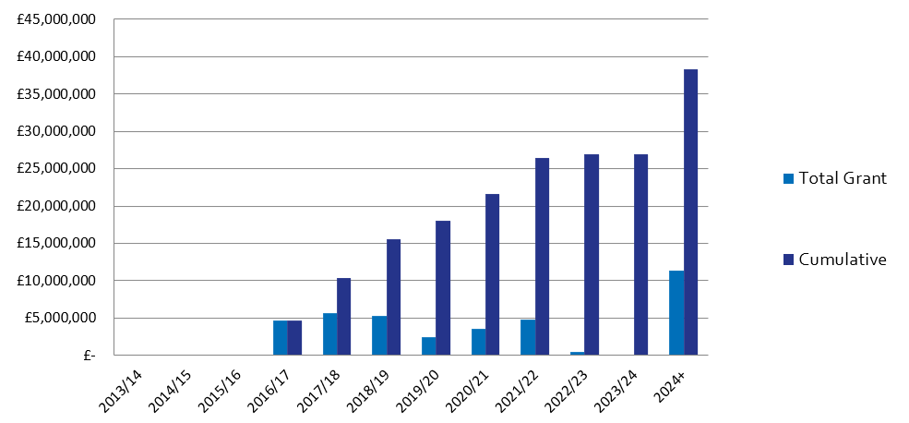
 |  |  |  |  | Q1 | Q2 | Q3 | Q4 |  | In Year Actual
 |  |  |  | Grant | £0 | £0 | £0 | £0 |  | £0
 |  |  |  | Loan | £0 | £0 | £0 | £0 |  | £0
 |  |  |  | Housing Completions | 3 | 24 | 0 | 0 |  | 27
Planning Consents |  | Starts on Site |  | Housing Completions |  |  |  |  | Grant Payments
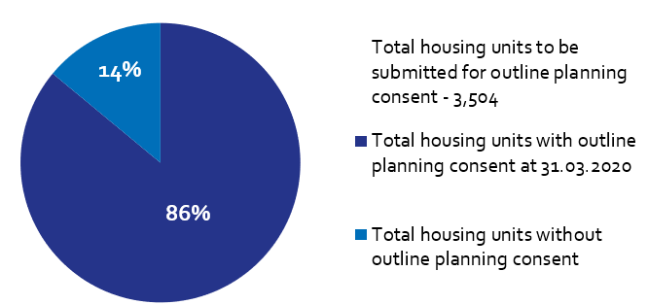 |  | 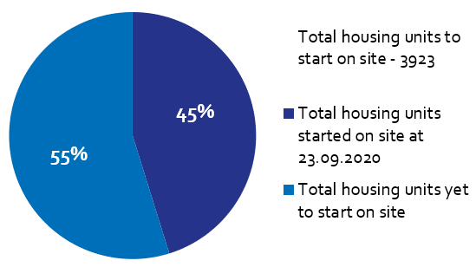 |  | 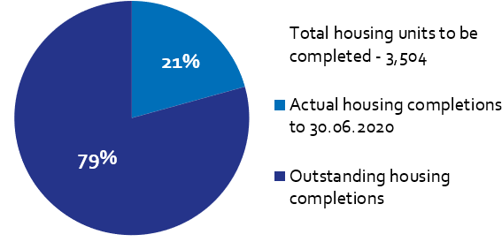 |  |  |  |  | 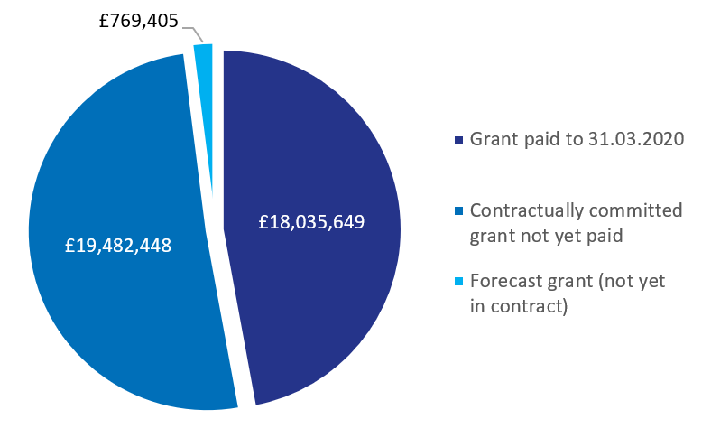
Of the Homes England residential City Deal sites, only Pickering’s Farm is yet to achieve planning consent. A refusal against the scheme’s masterplan was received this quarter. |  | Housing starts have been claimed for 1,773 units on Homes England City Deal sites to date, out of a total 3,923 units (including Walton Park Link and Cottam Brickworks). |  | There have been 749 housing completions to date on Homes England City Deal sites.  There were 24 housing completions during this reporting period. |  |  |  |  | To date, £18,035,649 has been paid to LCC as grant, with a further £19.4m contractually committed across Homes England City Deal sites.

